Career connected learning programs provide awareness, exploration, and launch experiences to help youth identify their career pathway, which may include college, the trades, military, entrepreneurship, workforce advancement or a combination. The goal is to expose them to a diverse range of opportunities to help them build experience and clarity around their goals and empower them to pursue experiences that are meaningful.
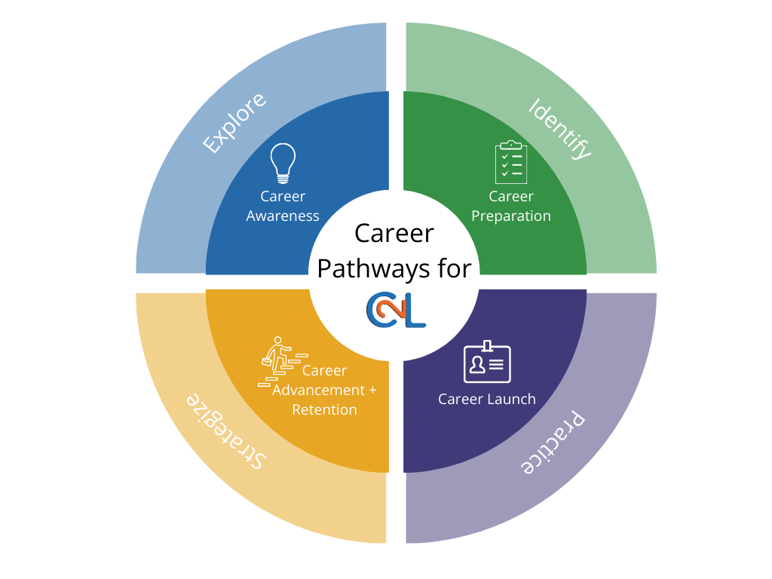

C2L – PHL Experiences for Youth Workforce Development
Experiences | Purpose | What Youth Do
Career Awareness  Learning about work | Provide opportunities for youth to explore:  - Themselves  - Education options  - Career options  - Real-world job expectations | Youth discover:  - Personal interests, strengths, aspirations, passions, values, and beliefs  - Skills for education, training and work  - Potential opportunities and supports
Career Preparation  Learning through work | Provide opportunities for youth to identify:  - Education options  - Career options  - Which options seem like a good fit | Youth learn more about:  - College pathway  - Trades pathway  - Military pathway  - Workforce pathway  - Entrepreneurship pathway
Career Launch  Learning at work | Provide opportunities for youth to practice:  - Skills  - Solving problems  - Communication  - Working in diverse teams  - Time management  - Set career goals, create a plan and follow through | Youth develop:  - Applied academic knowledge and critical thinking  - Effective relationship and workplace skills (sometimes called “soft skills”)  - Employability skills  - Connections to more opportunities  - Plans that will move them toward their career goals
Career Advancement & Retention  Growing through work | Provide opportunities for youth to strategize:  - Network with professionals from the field of their interest  - Take advantage of mentorship opportunities | Youth develop:  - Personal branding and communication skills, self-confidence  - Deep rooted connections to their field of interests

Download the Career Connected Learning Guidebook for procedures, processes, activity ideas and examples.
Possible Levels of Intensity for Implementation
Beginner | Intermediate | Advanced
Add a career activity type to your current program culture and activities. Do occasional activities focused on career awareness, exploration and preparation. Typically, you would start here with youth who have very limited experiences with career exposure. | For youth who have some experience with career exposure, plan and implement regular activities that focus on career awareness, exploration and preparation. | Adapt the career connected learning model as the overall theme and organizing principle for your program. You might even rename your youth workforce program to emphasize its focus on career awareness, exploration and preparation activities.

