ACEs or Adverse Childhood Experiences are traumatic events that occur during childhood. A study conducted between 1995 and 1997 by the Centers for Disease Control and Prevention and Kaiser Permanente examined the relationship between early childhood adversity and the effects on long-term health. The study found that the long-term impact of ACEs determined future health risks, chronic disease, and premature death. Below is a graphic displaying the original 10 ACEs. The list has been expanded to include discrimination, poverty, racism, other violence, intergenerational and cultural trauma, separation, other big changes in life, bereavement and survivorship, and adult responsibilities as a child.

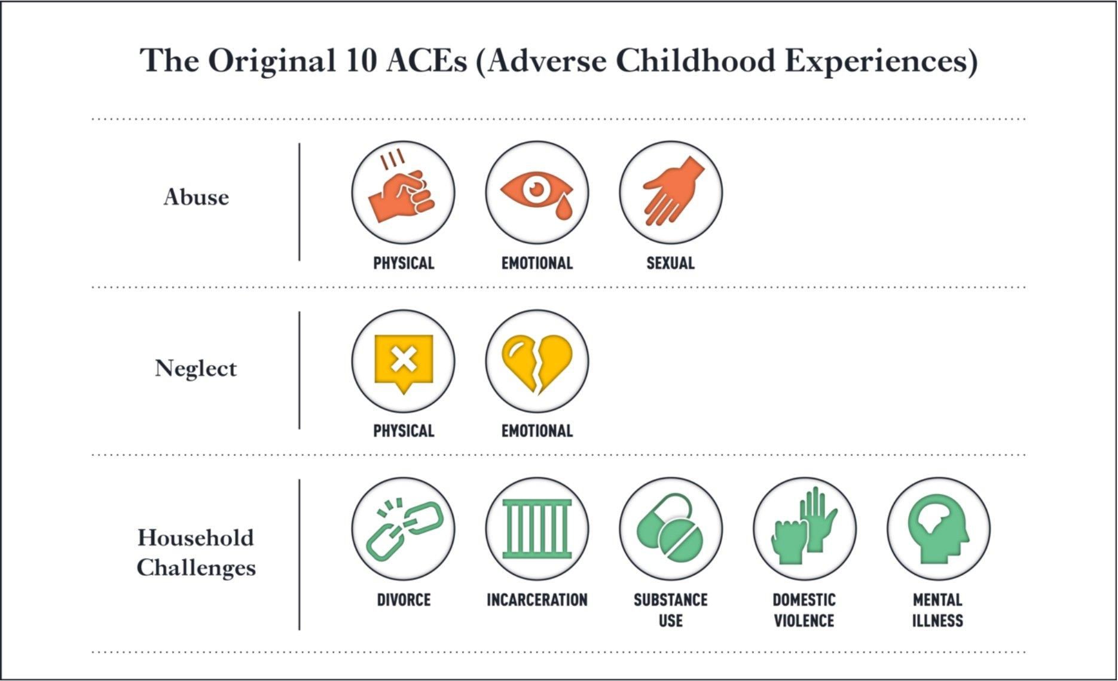

QUICK FACTS
- Two thirds of adults reported experiencing at least 1 ACE during childhood.
- ACEs have been linked to long-term health conditions including heart disease and depression.
- Some youth are at greater risk of one or more ACEs due to historical, social, and economic environments in which families live, with a higher correlation due to poverty and race.
- Youth who experience an ACE are more likely to exhibit negative and risky behavior.
SIGNS OF POTENTIAL TRAUMA
- Sudden changes in behavior such as social withdrawal, violent outbursts, or self-harm
- Physical symptoms such as headaches, back or chest pain, or upset stomach
- Emotional symptoms include sadness, anger, irritability, anxiety, and trouble focusing

WAYS TO SUPPORT YOUTH
- Create safe, stable, and nurturing relationships and environments
- Education and awareness. There are several resources available online, including the Child Trauma Toolkit for Educators: https://www.nctsn.org/sites/default/files/resources/child_trauma_toolkit_educators.pdf

HOW TO HELP YOUTH COPE
- Safety - Assure youth they are in a safe environment free from harm, danger, and re-traumatization.
- Trustworthiness and transparency – Foster trust through open and honest communication and maintain consistency and reliability in interactions.
- Peer support – Promote peer support groups and mentorship opportunities with others who may have experienced a similar trauma.
- Collaboration – Work collaboratively with others and recognize the contributions of everyone involved in the care process.
- Empowerment, voice, and choice – Encourage self-advocacy and involvement in decision-making while recognizing and building on their strengths and resilience.
- Connecting to resources – Youth may need further assistance to help them cope like mental health support. There are many resources available in the Philadelphia area. If you aren’t sure where to start looking, check out the National Alliance on Mental Illness or NAMI’s Philadelphia website for a list of resources: https://namiphilly.org/resources/local-resources/

Interested in expanding your learning on trauma-informed care? Check out this resource from the You for Youth (Y4Y) Archives: https://y4yarchives.org/y4yclickandgo/trauma-informed-care/2847

A copy of the original ACEs questionnaire can be found at the following link if you are interested in understanding about what goes into the ACEs score: https://www.ncjfcj.org/wp-content/uploads/2006/10/Finding-Your-Ace-Score.pdf.

https://www.cdc.gov/violenceprevention/aces/about.html
https://www.cdc.gov/aces/about/index.html

