Partnership Development Model
The process of growing a partnership is developed in the four stages: Forming, Storming, Norming and Performing.
- Forming- Potential partners begin to familiarize themselves with each other attempting to understand roles, common goals and how to function as partners.
- Storming- Partners are able to discuss issues, generate solutions and develop a plan to achieve mutual understanding
- Norming- The partnership starts to arrive at a more cohesive and collaborative team functionality.
- Performing- The partnership had reached its full potential in terms of efficiency and effectiveness
During the forming stage of partnership development, use this template to take notes at the initial potential partnership meeting to determine if the partnership is appropriate. If a partnership does not align, save this document for future notes. See below for an example.

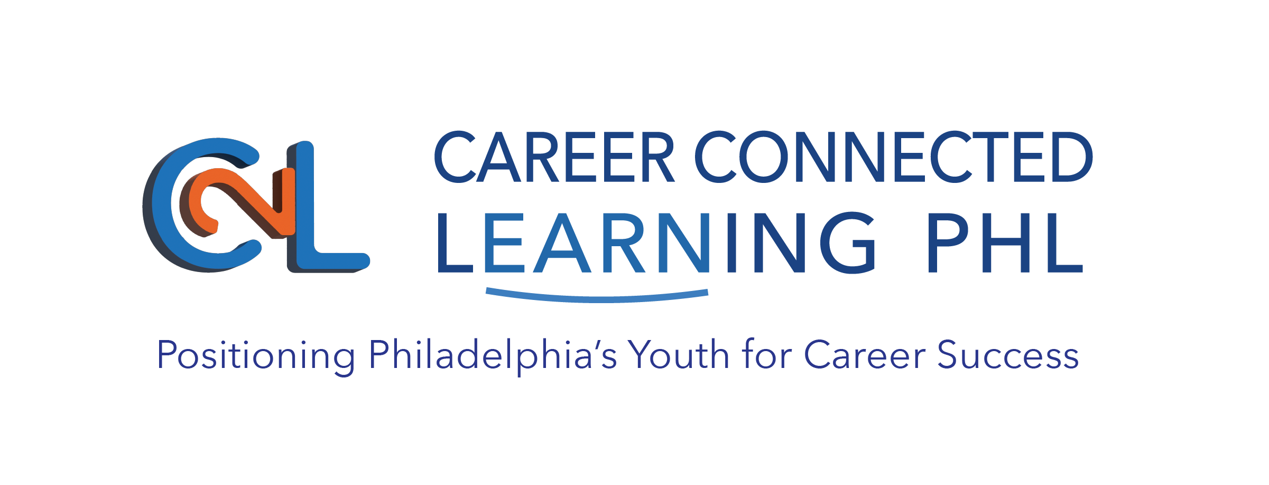

Type of Partnership: (circle one of the following)
Provider to
Business, Community, Employer, Provider, School
Provider: Being the Best for YOUth | Provider: Angelou’s Angels
Goal(s)  - Partner with an entity that will provide a focus on specialized training modules: technical, behavioral | Goal(s)  - Increased youth attendance, enrollment and participation
Skills:  - Creating tables using Microsoft Excel  - Effective Communication  - Conflict Resolution  Strengths:  - Creating curriculum based on youth interest  - Connecting employers to necessary training materials  - Remaining connected to youth after graduation  Weaknesses:  - Small facility  - Low Staff  - Limited technological access  Interests:  - Assessing youth capabilities before they start training | Skills:  - Canva  - Time Management  - Providing Feedback  - Coaching  Strengths:  - Identify the target professions  - Established partnerships with several surrounding businesses  - Providing on site training for the employers of the worksites  Weaknesses:  - Engaging participants  - Delivering instructions in various formats  Interests:  - Deliver ROI to employers and workers  - Coordinating workforce-development centrally
Desired Outcome:  Employers of worksites are more capable of embedding soft skills in service-learning projects and holding youth accountable. | Desired Outcome:  Following one year of partnership: increase enrollment by a minimum of 15%, at least 60% of youth attend 3 days a week, each youth completes at least 2 assigned projects.
Availability to Meet:  Monday, Wednesday and Thursday 12pm-3pm | Availability to Meet:  Tuesday, Wednesday, Thursday 1pm-4pm  Monday 8am-9am
Action Steps: | Action Step:
Notes:

Type of Partnership: (circle one of the following)
Provider to
Business, Community, Employer, Provider, School
(Provider Organization/Worksite) | (Potential Partner)
Goal(s) | Goal(s)
Skills:  Strengths:  Weaknesses:  Interests: | Skills:  Strengths:  Weaknesses:  Interests:
Desired Outcome: | Desired Outcome:
Availability to Meet: | Availability to Meet:
Action Steps: | Actions Steps:
Notes:

