Structured reflection practices help youth develop emotional intelligence and interpersonal skills. It also increases their awareness of how they learn, encourages them to take responsibility for their learning, and helps them recognize and appreciate their personal and professional growth. Below, you will find open-ended question starters that support four areas for youth to reflect on.
Help youth focus on social-emotional learning
- What was your favorite moment…..?
- How did you feel when you faced a challenge during…..?
- Can you describe a time when you….?
Help youth become more aware of how they learn
- Which activity helped you understand….the best, and why?
- What strategies did you use to solve a problem you encountered while….?
- How did you approach……..?
Help youth take responsibility of their learning
- What role did you take on in …?
- How did you prepare yourself for the tasks you were assigned?
- If you could do one thing differently next week, what would it be and why?
Help youth see growth in their learning
- How do you think your understanding of ….has changed since you started this project?
- What are you most proud of accomplishing in…this week?
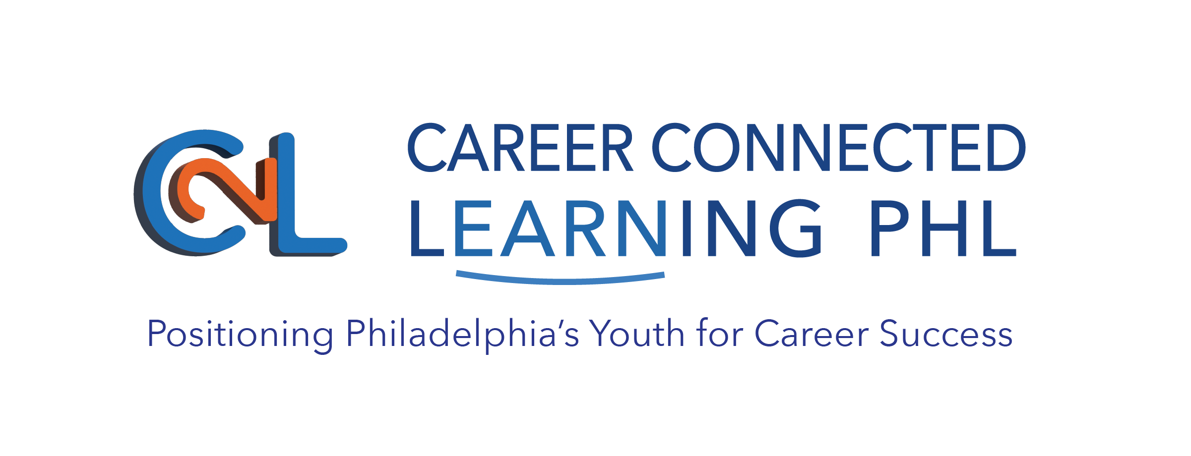
- What new skills or knowledge did you gain from….?

