Objective:
This template is designed to help coaches help youth reflect on their experiences, learning, and personal development. It encourages critical thinking and self-awareness, guiding them toward understanding their progress and identifying areas for growth.

Step 1: Reflect on the Experience
- What task or project did you recently complete?
- How did you feel during the process?
- What were the most challenging parts of this task or experience?
- What did you enjoy the most about this task or project?

Step 2: Evaluate Your Performance
- What skills or strengths did you use to complete this task?
- Did you encounter any difficulties, and how did you handle them?
- What would you do differently next time to improve your performance?
- Did you meet your initial goals or objectives? Why or why not?

Step 3: Plan for Improvement
- Based on what you learned, what specific areas do you want to improve?
- How can you apply the skills you’ve developed in future tasks or projects?
- What support or resources would help you continue growing in these areas?
- How will you track your progress and measure your improvement moving forward?

Step 4: Looking Forward
- What new goals do you want to set for yourself based on this experience?
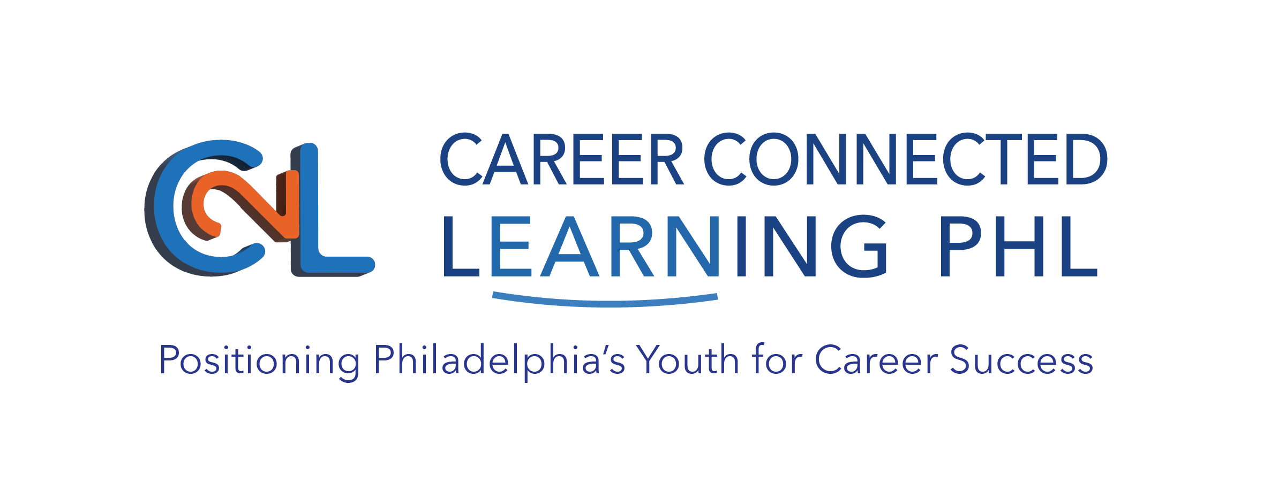
- How do you plan to achieve these goals?
- What’s the first action you’ll take toward these new goals?

