In your breakout rooms
- Review the example program needs listed below
- Develop a SMART learning Objective
- Choose one person from your group to share final SMART Learning Objective in the main session

Child Development Center Program

- 15 youth participants aged 16 – 18, partnered with three local daycare centers
- The daycare centers would like to support interested youth in learning basic childcare skills.
- Program is focusing on improving responsibility, empathy, and communication skills while working with daycares to provide hands-on experience in a supervised environment.
- Program would like youth to understand early childhood development.

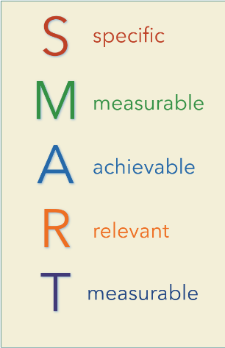
Example – Youth will plan and execute five educational activities at a local daycare serving children 4 and 5 years of age with feedback from supervisory daycare staff, while receiving training on early childhood development, over the 8-week program to develop responsibility and empathy.

In your breakout rooms
- Review the example program needs listed below
- Develop a SMART learning Objective
- Choose one person from your group to share final SMART Learning Objective in the main session

Transportation Careers Program

- 30 youth participants aged 18 - 24, partnered with three local automotive repair shops
- Automotive repair shops would like to support career exposure activities for older youth in hopes of gaining new employees
- Program is focusing on enhancing technical skills, such as diagnostic s and mechanical repairs, while also emphasizing workplace safety and customer service skills.
- Participants are expected to gain practical knowledge and industry certifications to prepare them for entry-level positions in the automotive industry.

Example – Youth will accurately diagnose and repair at least 3 automotive issues supervised by certified technicians (achievable/measurable), within the 8 – week program to gain practical experience and preparation for entry-level positions in the automotive industry.

In your breakout rooms
- Review the example program needs listed below
- Develop a SMART learning Objective
- Choose one person from your group to share final SMART Learning Objective in the main session

The Arts Program
- 20 youth participants aged 13 -19 would like to collaborate with the local art gallery and community center
- Program would like to engage youth in developing visual arts skills and creating a public art exhibit
- Program aims to improve youth participants artistic techniques and provide opportunities for self-expression, while also addressing social-emotional learning needs such as self-awareness and self-management.

Example – Youth will create a series of five original paintings and will be critiqued based on creativity, technique, and presentation, guided a professional artist, and exhibit them by the end of the 6-week program to develop their artistic skills and gain public exposure.

