C2L doesn’t happen in isolation. It relies on three core groups working together – the program, families and caregivers, and employers/worksites. This trifecta of trust is what allows the youth at the center to thrive. When programs communicate well with families, and employers feel supported by the program, youth benefit. If any point in this triangle weakens, the whole structure wobbles. Triangles are known to be the strongest shape in architecture and design. Because no matter where pressure is applied, the force is evenly distributed through all three sides. Unlike squares or rectangles, which can collapse under pressure if one side is weak, a triangle holds firm. Each side supports the other, and the shape stays stable and intact.
What does this teach us about the trifecta of trust?
- It tells us that when programs, families, and employers are all engaged and working in sync, the structure of support around youth is stable and resilient.
- If one side weakens, say an employer disengages or families feel unheard, the whole structure becomes more vulnerable. But when each side leans in and supports the others, we create something strong enough to hold the weight of real opportunity and transformation.
- Just like in engineering, strength doesn’t come from one beam, it comes from the way all sides work together.

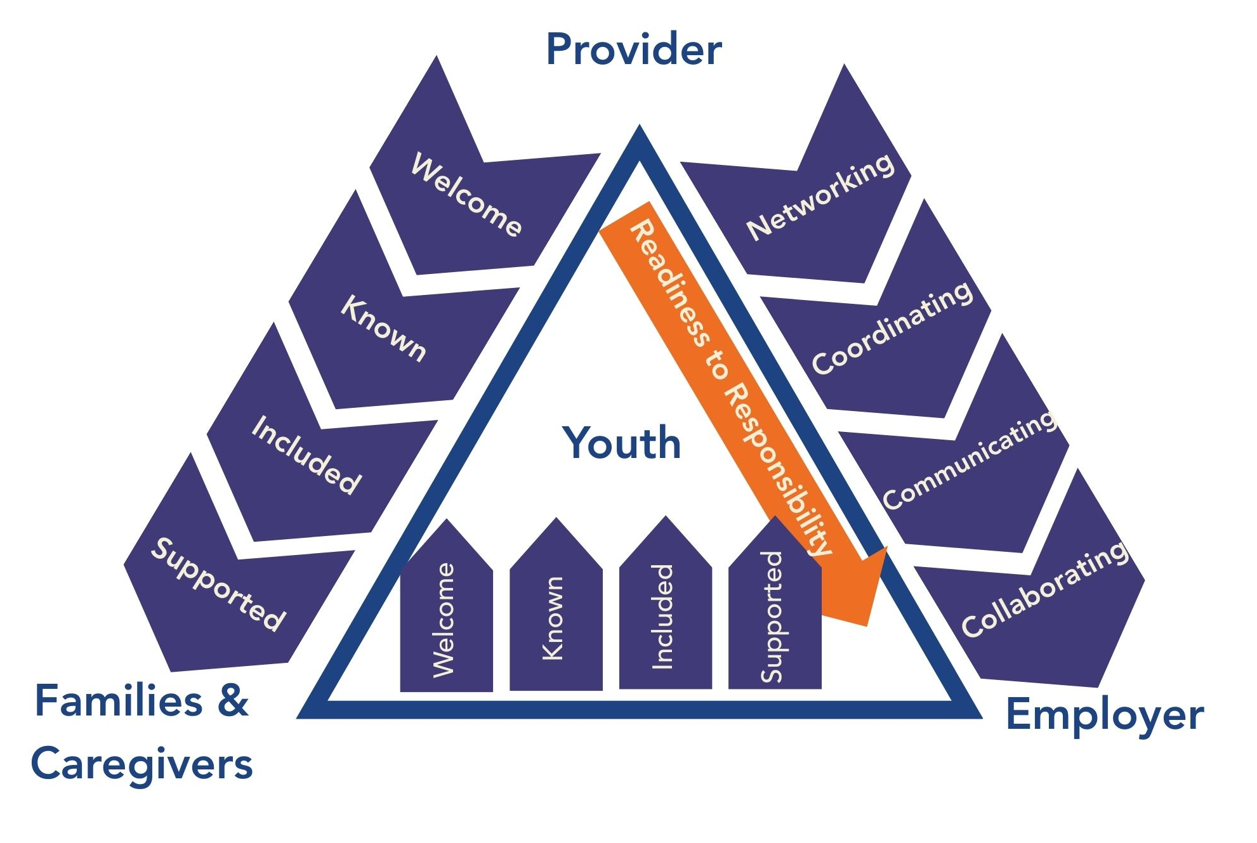

Building Trust with Families & Caregivers
In order to build trust with families and caregivers we have to move them along this continuum.
- Welcome them. First impressions matter, so create a friendly and inviting environment that encourages families to engage with the program. This can help set the tone for a strong relationship.
- Being known. Take the time to learn about families – their culture, needs, and aspirations for their children. Show genuine interest and respect for their unique experiences. This requires staff to invest time in genuine relationship building.
- Include families and caregivers. Actively invite families to participate in decision-making events and activities. When families feel included, they become invested in the program’s success.
- Support families and caregivers. With these strong relationships in place, you can now dig in deeper, providing resources, guidance, and assistance tailored to family needs. By helping them navigate challenges and celebrate successes, you strengthen their connection to the program.

Building Trust with Employers
As providers, we play an important role in building trust with employers.
- Network. Programs introduce themselves to local businesses, attend community events, and establish an initial presence. At this stage, employers are simply getting to know who you are and what you do. The goal is visibility and mutual curiosity, not commitment yet.
- Coordination. This is where the structure is formed. Programs and employers begin aligning calendars, drafting job descriptions, and setting expectations. At this stage, we’re building the framework that will guide youth placements. Coordination sets the tone for what’s coming, it needs to be clear, organized, and mutually agreed upon.
- Ongoing communication. This is frequently where trust is either strengthened or weakened. Programs must check in regularly with employers, especially if youth are struggling to transition from readiness to responsibility. Communication shouldn’t only happen when there’s a problem, it should be proactive, responsive, and focused on partnership.
- Collaboration. This is where employers and programs assess what’s working, what’s not, and make adjustments together. Collaboration means shared problem-solving, innovation, and investment. It’s also where employers begin to see themselves not just as hosts, but as co-educators in the career journey of young people.

Building Trust with Youth
With youth, those same four pillars apply as they do with families and caregivers. When they feel these things consistently, they show up fully, take risks, ask for help, and grow.
- Welcome means youth feel like they belong in the space.
- Known means staff understand their strengths and goals.
- Included means students have a say in decisions affecting them.
- Supported means they have coaching, feedback, and a safety net when things go wrong.

To learn more about the Trifecta of Trust, review the Virtual PD, Rooted in Trust: Building Trust with Youth, Families, and Parents.

